1) Can we have multiple conatiners in a pod? Can we have similar conatiners in a pod? Lets say i have 4 conatiners, one of them has failed how would you check which container has failed?
Yes we can have multiple containers in a pod
No can’t have similar container in pod (container created with same image)
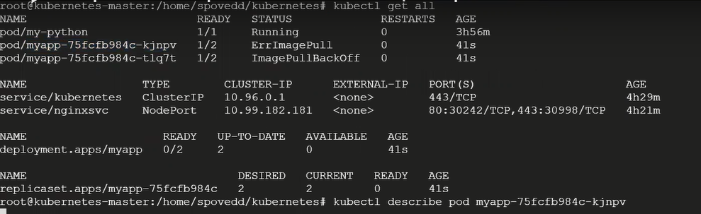
Failed container information
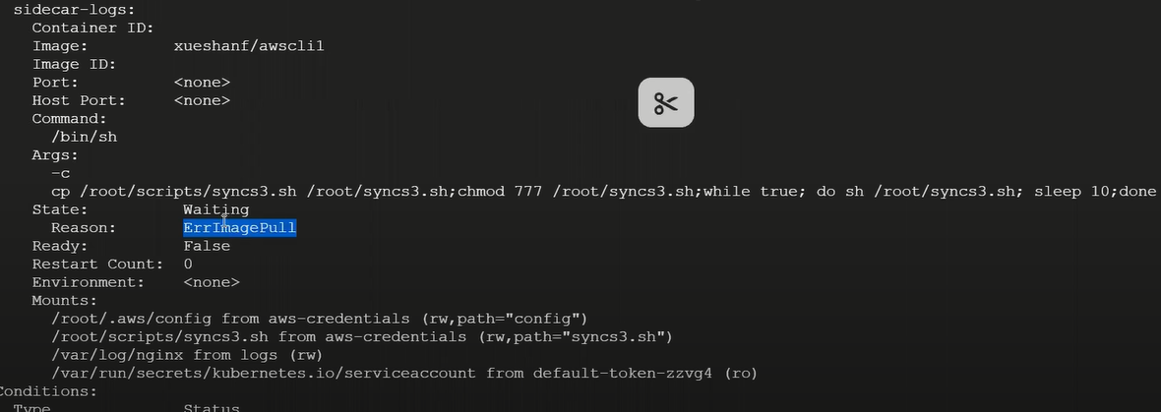
Running container information if exit code is 0 then your application is running successfully
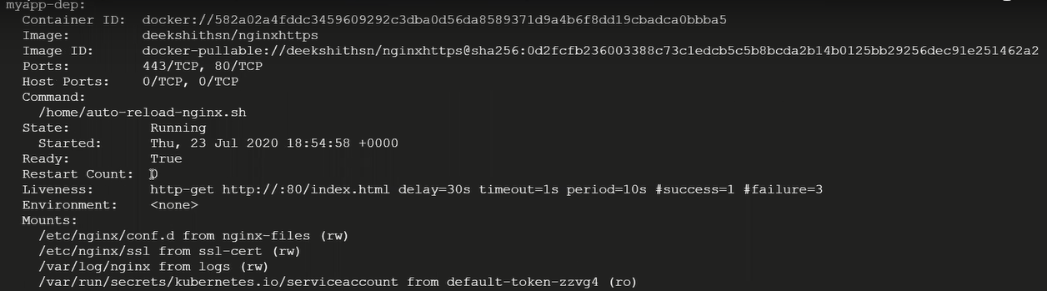

2) What is liveness and readiness probe? Why we need them?
Make your application highly available we use liveness & readiness probe
Video – readiness probe & liveness probe in kubernetes = 30minutes
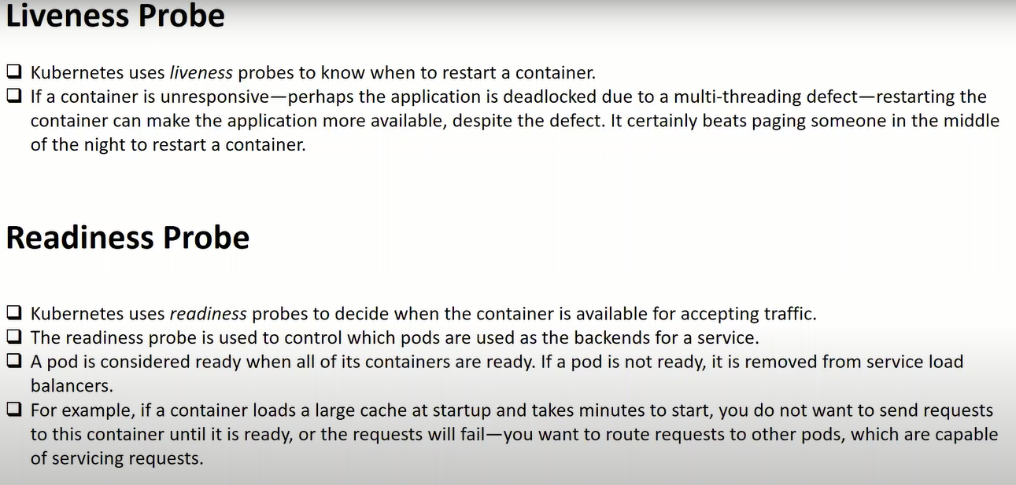

3) Have you worked on kubernetes monitoring? Which tools you have used?
Grafana & Prometheus = video see Monitoring

4) Can we deploy a pod on particular node? (https://github.com/DeekshithSN/kubernetes/blob/master/pod.yml)
Yes, I am going with node selector 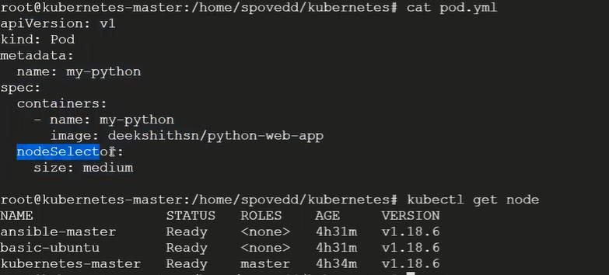
Specify the label to the node
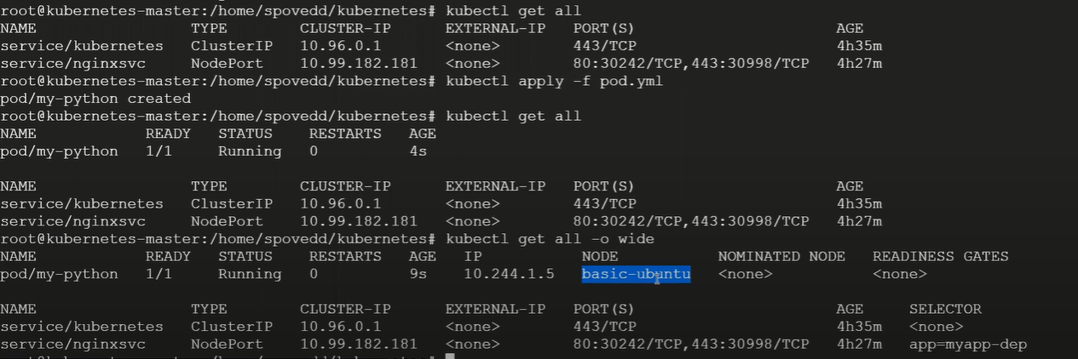

5) what is init container and side-car container?can you give simple scenario where we use these conatiners? ( Video = init containers and side-car containers in kubernetes )
init containers runs before your application containers runs and also it will executed to the success and kill itself, and also you have multiple init container it will going to execute one after the other, if second init container fail your deployment will also fail
side-car container just like helper for the application container and support

6) which one is default deployment strategy? how it works? (kubernetes/deployment-strategies/rolling-update/app-v1.yaml)
Rolling update – default deployment strategy 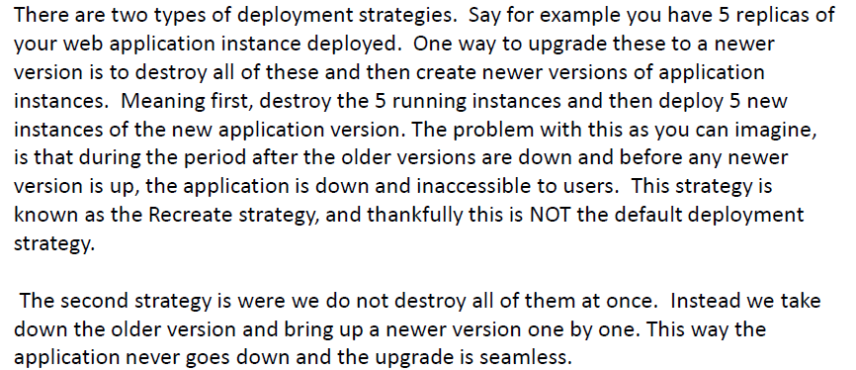

7) command to check the container logs in pod? 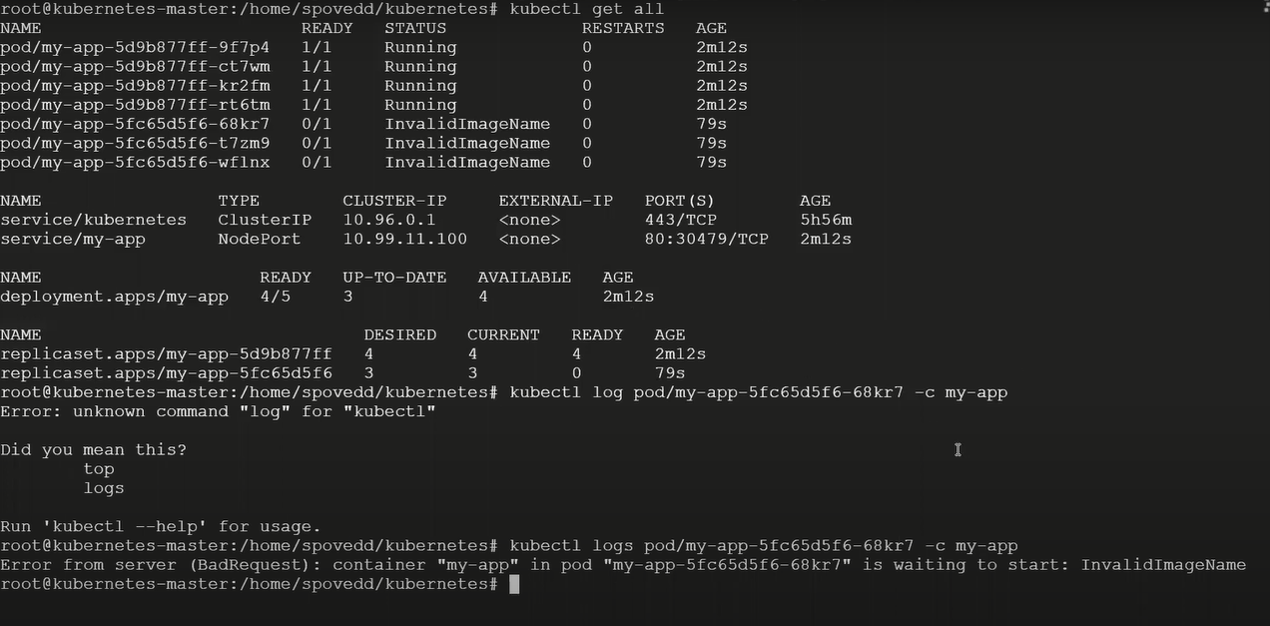
my-app is container

8) what are the types of services present in kubernetes?
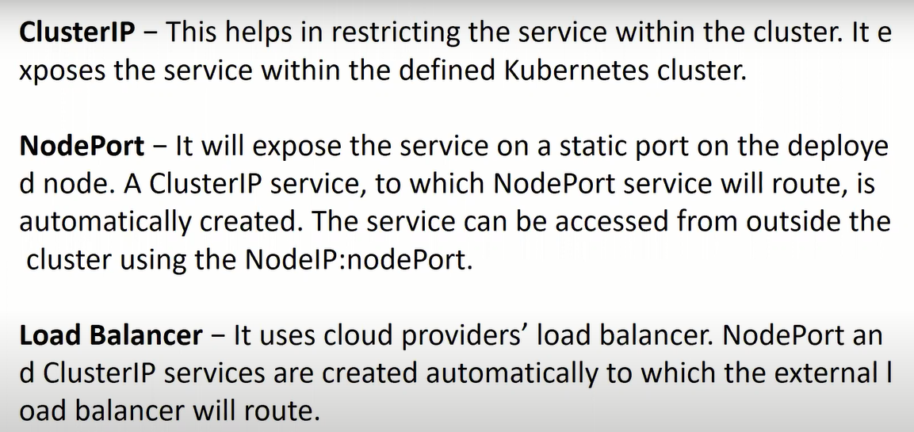

Application expose inside your cluster don’t want to available application the public then you can use cluster ip
Expose the application outside the world go for NodePort
9) What is the link between pod and service?
Service is created for pod not for deployment
In pod definition you define some label right this should be match with selector pod in a service

10) List objects you know in kubernetes?Give a brief about each object?
Deployment, pods, replica sets , services ,ingress controller , network policies, pod security policies, jobs & cronjob , statefullsets , etc.

11) Command to list pods and deployments?
Kubectl get all
Only pod – kubectl get po,deploy

12) why we can’t use docker swarm instead of kubernetes ? devops made easy answer video

